JOURNAL OF FOREIGN LANGUAGE SCIENCES

JFLS MANUSCRIPT TEMPLATE

[TITLE IN FOREIGN LANGUAGE] BOLD AND CAPITAL [size 13]
Author^{1*}, Author ² [Font 12]
¹ Full name of Author 1 [Font 12]
² Full name of Author 2 [Font 12]
*Email of corresponding author: vuvandai@hanu.edu.vn
Abstract [English, not exceeding 250 words] [Font 11]
Keywords [English, 03 – 05 word] [Font 11]
Tóm tắt [Vietnamese, not exceeding 250 words] [Font 11]
Từ khóa: [Vietnamese, 03 – 05 word] [Font 11]
Note: The above content is compulsory for papers written in all languages. If all the authors are foreigners, translation into Vietnamese will be done by the Journal.

Introduction [Heading 1][size 13]
The novel coronavirus disease 2019 (COVID-19) emerged at the end of December 2019 caused an unprecedented phenomenon when students of all levels were forced to study online because of class suspension [Size 12]

Literature review [Heading 1] [size 13]
Since the first discussions of Mobile Assisted Language Learning (MALL), a lot of research has been conducted on its benefits and acceptance by various groups of learners and teachers at the high school and university levels (Hoi & Mu, 2021; Maheshwari, 2021; Tran, 2020).
Studies on the Mobile English Language Learning (MELL) program shared the aforementioned features of using mobile devices for learning English, but further investigated how mobile devices could enhance English learners’ language proficiency (Elaish et al., 2019; Tran, 2020). [Size 12]
Methods [Heading 1] [size 13]
Pedagogical Setting & Participants [Heading 2] [size 12]
Describing the research context and the sampling methods

Design of the Study [Heading 2] [size 12]
Defining the research type that the researchers employed to collect the data.

Data collection & analysis [Heading 2] [size 12]
Describing the procedure of the study, tools and methods of analysis to respond to the research questions.

Results/Findings and Discussion [Heading 1][size 13]

Results [Heading 2][size 12]
Presenting the results under the lights of the research questions/hypotheses. [size 12]
Making use of charts, figures, and tables to present the results.
Table 1. Purpose of Using Mobile Devices
Purpose | M | SD | Frequency
 |  |  | Never | Rarely | Sometimes | Often | Always
Social Network | 4.26 | 0.72 | 0.6 | 1.8 | 7.0 | 52.5 | 38.1
Information Search | 4.23 | 0.73 | 0.2 | 1.9 | 10.9 | 49.1 | 37.9
Data in Table 1 shows that browsing social networks and the Internet to search for information were the two most popular aims (M = 4.26 and 4.23, respectively), while online shopping and online learning ranked the lowest (M = 2.90 and 2.64, respectively).
Table 2. Differences in Usage of Mobile Devices for Online Learning
 |  | N | M | SD | t | Sig. (2 Tailed) | Mean Difference | Lower | Upper
Target Learners | Uni. Ss | 243 | 2.95 | 0.90 | 6.20 | 0.00 | 0.50 | 0.34 | 0.66
 | School Ss | 374 | 2.45 | 1.08
Table 2 shows that there is a significant difference in scores for university students (M = 2.95; SD = 0.90) and school students (M = 2.45, SD = 1.08; t(617) = 6.20; p = 0.00, two-tailed).
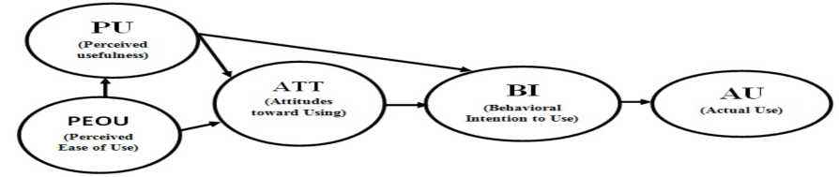
Figure 1. Technology Acceptance Model (TAM; Davis, 1986)

Discussion [Heading 2][size 12]
Summarizing the results of the studies.
Interpretation of the results
Relationship of the current study to previous research

Conclusion [Heading 1][size 13]
Summarizing the results and findings of the studies.
Presenting the limitations of the studies and suggestions for future studies.

Acknowledgments [Heading 2][size 12]
Acknowledging contributions to this research article in the order that best represents the nature and importance of those contributions, such as intellectual assistance and funding support.

References [APA seventh edition] [Heading 1]
Elaish, M. M., Shuib, L., Ghani, N. A., & Yadegaridehkordi, E. (2019). Mobile English language learning (MELL): A literature review. Educational Review, 71(2), 257–276. https://doi.org/10.1080/00131911.2017.1382445
Hair, J. F., Hult, G. T., Ringle, C. M., & Sarstedt, M. (2017). A primer on partial least squares structural equation modeling (PLS-SEM) (2nd ed.). Sage Publications.
Hoi, V. N., & Mu, G. M. (2021). Perceived teacher support and students’ acceptance of mobile‐assisted language learning: Evidence from Vietnamese higher education context. British Journal of Educational Technology, 52(2), 879–898. https://doi.org/10.1111/bjet.13044

Biodata [Heading 2][size 12]
Write approx. 50 words, including your job position, institution, country, teaching experience, and research interests.
------------------------------------------------------------

